Gaelscoil Neachtain

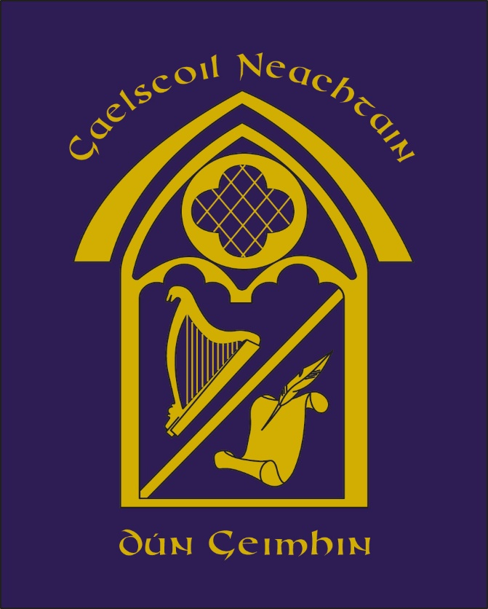

POLASAÍ FRITHBHULAÍOCHTA
Anti-Bullying Policy

September, 2022.
MISSION STATEMENT
The staff and management of Gaelscoil Neachtain aim to provide a safe, caring environment in which pupils have the opportunity to reach their full potential, within an Irish-medium immersion environment.
The staff and management wish to create a stimulating atmosphere in which both pupils and staff are happy and secure and in which they have every opportunity to grow and develop and to get the very best from their abilities.

BULLYING
All members of the Gaelscoil Neachtain community, including Board of Governors, teaching and non-teaching staff, pupils and parents should have an understanding of what bullying is and be familiar with the Gaelscoil’s policy on bullying. The aim of this policy is to help members of the school community deal with bullying when it occurs and, even more importantly, to prevent it.
All members of our school community have the right to learn and work in a secure and safe environment, one in which they can express their views knowing that they will be listened to with respect. They also have a responsibility to contribute, in whatever way they can, to the protection and maintenance of such an environment.

In drafting this policy, guidance has been taken from the Northern Ireland Anti-Bullying Forum (NIABF).

DEFINITION
The Board of Governors of Gaelscoil Neachtain fully endorse the NIABF’s definition of bullying ‘…as the repeated use of power by one or more persons intentionally to hurt, harm or adversely affect the rights and needs of another or others.’

Bullying is deliberately hurtful behaviour which is repeated over a period of time. It is an attack on the child’s right to feel safe and happy at school.
We do not use this word to define the general rough and tumble of school life. We do our best to ensure that the children can distinguish between falling out with each other and being bullied.

The Board of Governors of Gaelscoil Neachtain also adhere to Pastoral Care in Schools; Promoting Positive Behaviour (DE, 2001) Paragraph 125 which states -
“As well as ensuring that pupils who are bullying are dealt with in accordance with accepted school policy and procedures, it will be necessary to work with these pupils to try to help them change their unacceptable behaviour.”

FORMS OF BULLYING
- It may be physical: hitting, kicking, pushing, pinching, spitting
- It may be verbal: name calling, teasing, ridiculing personal appearance, mannerisms or way of speaking, making hurtful comments or spreading rumours
- It may involve interfering with another pupil’s property, by stealing, hiding or damaging it;

- It may involve teasing or spreading rumours about another pupil or his/her family;

- It may be social: excluding a pupil from a group or an activity

- It may involve writing offensive notes or graffiti about another pupil;

- It may be psychological: belittling a pupil’s abilities and achievements, causing them to lose self-esteem

- It may take the form of Cyber-activity (through technology such as mobile phones. i-pads and internet)

- It may be homophobic (related to perceived or actual sexual orientation)

- Racist (related to skin colour, culture and religion)

- Sectarian (related to religious belief and/or political opinion)

The Responsibilities of Staff

Our staff will:
- foster in our pupils, self-esteem, self-respect and respect for others;

- demonstrate by example the high standards of personal and social behaviour we expect of our pupils;

- Incorporate Circle Time, PDMU units of learning and assemblies into class time-tables to raise awareness among the children and to help develop anti-bullying attitudes.

- discuss bullying with all classes, in both Irish and English where appropriate, so that every pupil learns about its effects;

- be alert to signs of distress and other possible indications of bullying;

- encourage pupils to come forward with information about possible incidents of bullying;

- listen to children who have been bullied and act in accordance with policy guidelines;

- report suspected cases of bullying to the Designated Teacher and Principal

- follow up any complaint by a parent about bullying and report back;

- deal with observed instances of bullying promptly and effectively, in accordance with agreed procedures

The Responsibilities of Pupils

Anyone who becomes the target of bullies should:
- Report this as soon as possible to the class teacher, Designated Teachers, the Principal or any member of staff with whom they feel comfortable

We expect our pupils:
- Not to become involved in any kind of bullying;

- To report to a member of staff any witnessed or suspected instances of bullying.

The Responsibilities of Parents

We ask our parents to support their children and the Gaelscoil by:

- watching for signs of distress or unusual behaviour in their children, which might be evidence of bullying;

- advising their children to report any bullying to the class teacher, the Principal or any member of staff with whom they feel comfortable,

- reassuring them that appropriate action will be taken;

- keep a written record of any reported instances of bullying;

- informing the school of any suspected bullying, even if their children are not involved;

- co-operating with the school, if their children are accused of bullying, to try to ascertain the truth.

Procedures for Dealing with Incidents of Bullying Behaviour

Each reported case of bullying will be dealt with individually. Follow-up action will be guided by the resource Effective Responses to Bullying Behaviour. (NIABF)

Reporting of an Incident

When a bullying incident is reported, the information will be passed on to the following people:
- the teacher of any child involved
- the Designated Teacher for Child Protection.
- the Principal

Investigation of the Incident

- This will normally be carried out by the Designated Teacher for Child Protection, in co-operation with any class teachers concerned.
- Facts will be gathered and recorded.
- The behaviour will be checked in accordance with what constitutes bullying behaviour as defined in Gaelscoil Neachtain’s current policy.
- Records for any previous incidents will also be checked.

On the basis of this initial assessment:

- Appropriate intervention will be decided upon in line with Effective Responses to Bullying Behaviour (NIABF).
- Effective communication amongst all parties will be ensured.
- Consideration will be given to the possible need for:
  - Parental involvement
  - Special Educational Needs Coordinator (SENCO) involvement
  - Risk assessment
  - External agency involvement e.g. the Child Protection Support Service for Schools (CPSS), PSNI.
(This list is not exhaustive.)

- Monitor the on-going effectiveness of chosen intervention/strategy.
- Record actions taken and outcomes achieved.
- Review the outcomes after an agreed time-scale to determine whether further action is required and progress accordingly.

Implementing the above process will provide opportunities for self-reflection, development and learning for all parties concerned, resulting in the effective management of bullying incidents. This reflection should inform and guide the on-going review and development of the school’s anti-bullying policy, procedures and practice.

THE PREVENTATIVE CURRICULUM

We recognise that the Gaelscoil plays a significant part in promoting positive behaviour by providing pupils with good lines of communication with trusted adults, supportive friends and an ethos of safeguarding and protection.

The Gaelscoil community will therefore:
- establish and maintain an ethos where children feel secure, are encouraged to talk and are listened to
- ensure that all children know there is an adult in the school whom they can approach if they are worried or in difficulty
- follow the curriculum for Personal Development for Mutual Understanding, an area which equips children with the skills they need to stay safe from harm and recognise to whom they should turn for help should the need arise
- Facilitate anti-bullying training for all Governors and staff
- Facilitate anti-bullying workshops for children and parents
- Organise a variety of activities throughout the school, during Anti-Bullying Week, for e.g. Creating Posters, Odd Socks Day, Assemblies etc

E-SAFETY

- Pupils will be taught to use e-mail and the internet responsibly in order to reduce the risk to themselves and others.
- Rules for Responsible Internet Use will be posted near computer systems.
- School guidelines on issues such as safe internet use will be made available to parents together with printed information and internet sites providing information for parents about safe access for children
- At the start of each school year, the IT co-ordinator will distribute relevant leaflets for internet safety to parents and children.

CYBER-BULLYING

Cyberbullying can be defined as the deliberate use of Information and Communications Technology (ICT), particularly mobile phones and the internet to bully.
School staff, parents and pupils aim to work together to prevent such behaviour and to act appropriately and effectively when it occurs.
Deliberate abuses, which happen outside school, but which impinge upon or affect school pupils and staff will be dealt with in line with the school’s Anti-Bullying Policy and where appropriate, external agency action.

We urge parents to monitor their children’s activity on all technological devices.

Parents please note: it is against the law for children of primary school age to access social networking sites, e.g. Facebook, Snapchat, WhatsApp, Instagram, Twitter, Tik Tok amongst others.

Grooming and inappropriate images of children

If school staff, parents or pupils suspect or are made aware of the following illegal acts it must be reported to the Designated Teacher immediately.
- A child under 16 enticed or coerced to engage in sexually explicit conduct on-line.
- Importing or transporting obscenity using telecommunications public networks.
- Knowingly receiving inappropriate images of children whether via the internet or other digital device (e.g. mobile phone)
- Images, which appear to be photographs, whether made by computer graphics or otherwise, are also covered under Sexual Offences legislation.

Links with other Policies

This policy is linked to the Gaelscoil’s Child Protection Policy, Pastoral Care Policy, Positive Behaviour Policy, Acceptable Use of Internet Policy, Digital Images and Mobile Phone Policy.

