Gaelscoil Neachtain

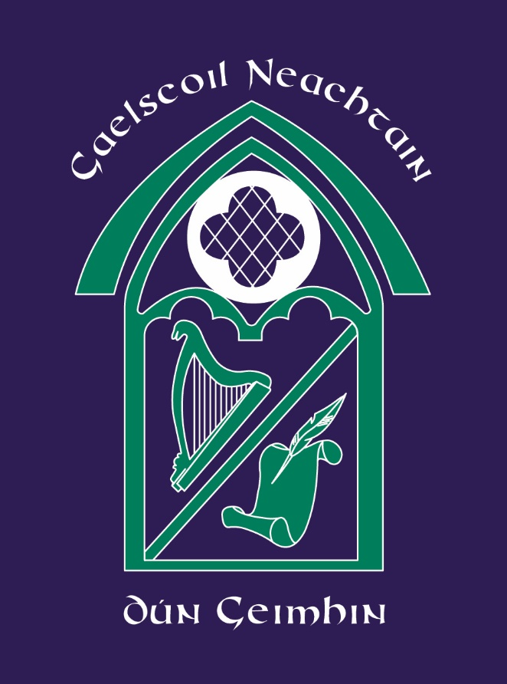

Pólasaí don Tréadchúram
Pastoral Care Policy

September, 2022.

Rationale
At Gaelscoil Neachtain we promote an atmosphere of mutual respect and co-operation which will contribute to the learning process and generate a positive and supportive atmosphere within the school community where every individual feels valued and cared for.

Pastoral Care concerns the child’s total well-being. Pastoral Care is composed of different policies and procedures which encourage each individual child to develop their full potential by catering for their spiritual, moral, emotional, intellectual, physical and social needs, in a safe and secure environment. Each child will be encouraged to develop personal, social and academic skills to prepare them for the “outside world”.

We recognise that parents and other services outside the school also have a central role. We strive to work in co-operation with each of these in order to fulfil our pastoral care ethos.

This Pastoral Care Policy applies equally during periods of exceptional closure.

Aims

Gaelscoil Neachtain aims -

- To ensure that each child feels valued and safe.

- We work to ensure that each child feels a part of the Gaelscoil community.

- We aim to build positive relationships with the children in our care with the aim of raising pupils’ social awareness, promoting positive attitudes and building their self-esteem.

- We aim to promote confidence and pride in our pupils as members of an Irish language, and wider, community.

- To nurture an appreciation, respect and love for the Irish language and culture

- We aim to enable the children to initiate and develop good relations with other children, teachers and other adults

- At Gaelscoil Neachtain we are aware of the need to help our children manage their present lives, as well as to help them prepare for the opportunities, responsibilities and experiences of adult life. We aim, therefore, to provide for the development of the pupil as a person as well as a learner.

- We aim to develop our pupils’ ‘life skills’– critical thinking, decision making, effective communication, learning from mistakes, which are necessary for their safety and health in today’s society.

- We aim to guide our pupils on both personal and educational matters and we seek to build up a community of children who care about each other and show respect for themselves and others.

- We aim to promote a partnership, and close working relationship, with parents/guardians whose views and wishes as first carers will be heard and respected to enable us to support their children’s learning.

- We aim to offer a framework of values and positive behaviour enabling our children to be self-reliant, motivated, self-disciplined and to make good choices in a moral context.

- We work to cultivate an understanding of the Spirit in human development.

Values
Every opportunity will be taken to praise our pupils for their contributions to the life of the Gaelscoil. Through positive daily experiences, in addition to curricular activities, we aim to communicate the following positive values and beliefs -
- Self-respect
- Honesty
- Integrity
- Tolerance
- Ownership of the Irish language
- Respect for others and their property
- Independence
- Co-operation
- Positive behaviour
- Reconciliation

SELF-ESTEEM
Gaelscoil Neachtain recognises that the most important aspect of education is the wholeness of the child. As a school we will encourage children to think positively about themselves and accept their own individuality. We believe that when a child’s self-esteem will be boosted then they feel valued in all aspects of Gaelscoil life.
The school will aim to promote positive self-esteem and confidence as these promote learning.

An Chomhairle Scoile / The School Council
The Pupil Council was established to give pupils a voice. It includes two representatives- one boy and one girl - from each of the classes from Ranganna 4-7 and meets once a month. The Council operates like any other committee and reports back the issues discussed to their class. The Council involves the children in decision-making within the school and allows children to express opinions and make staff aware of issues important to them in a forum where they are listened to and taken seriously.
The Council encourages:
- pupil involvement in improving school life for everyone
- pupils to work as partners with staff in developing a safe, caring and inclusive school community
- the involvement of the children in solving problems and resolving conflict
- pupils to respect school property and its upkeep

Liaison with Parents
We feel that we are in partnership with parents with regard to the education of their child. Mutual support and co-operation are essential elements in the fulfilment of our aims. Among the continuous activities we undertake to ensure responsiveness and input from parents are:
- Regular correspondence
- regular meetings (parents/teachers)
- workshops
- newsletters
- Gaelscoil website
- parental consultation
- annual reports
- charity events
- after-school activities
- Gaelscoil shows
- Spiritual activities
- Social activities

The School in the Community
Our aim will be to foster in our children an awareness of the wider community
- We will involve children in the support of charities and care for others
- We will encourage participation in community activities
For example:
  - Cultural activities such as Feis Charn Tóchair;
  - Sporting activities such as bliotzanna;
  - Parish activities.

Professional Development and Training
Pastoral Care is a central element of Gaelscoil Neachtain’s development plan and, as a result of this, the need to train and develop the staff is recognised. This development plan helps the staff focus on attitudes, values, skills and knowledge and this enables the school to fulfil its Pastoral Care role.
Continuous training is provided in interpersonal and teaching skills that help us help the child to learn. Training is organised in various ways, e.g. In-service courses or EA courses.

Liaison with services outside the school
We believe that good relations should be developed with external agencies that are in a position to help us protect the academic, emotional, personal, social and physical development of each child.

Formal Curriculum
Circle time, Personal Development and Mutual Understanding and the presentation of assemblies are included in each class timetable in order to gradually develop the knowledge, values, attitudes and skills that are required for positive living.

Monitoring and Evaluation
Monitoring is a continuous element of Pastoral Care. Pastoral Care is on the agenda of every staff meeting. Lines of communication are open between the Principal and every member of staff in the Gaelscoil and it is understood that it is the responsibility of each member of staff to use such lines of communication when required. Each member of staff has responsibility for this issue. Feedback is an important element of this responsibility.

IMPLEMENTATION

Roles and Responsibilities
- The Board of Governors has overall responsibility for Pastoral Care in Gaelscoil Neachtain.
- The Principal has overall responsibility for promoting Pastoral Care and fostering positive relationships. In addition, she, alongside the Pastoral Care Sub-Committee, will review and update the policy, inform and liaise with parents and initiate and ensure Pastoral Care is forefront in the School’s Development Plan.
- Teachers have responsibility for promoting Pastoral Care by:
- Helping children to make informed decisions
- Celebrating success
- Building up children’s self-esteem
- Encouraging assertiveness
- Encouraging sensitivity to others
- Developing effective communication
- Teachers build up a knowledge of pupils as individuals and take an interest in their special needs and all round development.
- Support staff will contribute to the promotion of Pastoral Care consistent with our policy.

Children may be signposted to the following agencies.
- CEOP/Thinkuknow

- Childnet

- Safer Schools App

SOME USEFUL LINKS AND CONTACT TELEPHONE NUMBERS: –

Gateway 028 70352221 (ask for the Duty Social Worker)

    - https://learning.nspcc.org.uk/safeguarding-child-protection/coronavirus

    - https://www.camhs-resources.co.uk/

    - https://www.childline.org.uk/info-advice/your-feelings/anxiety-stress-panic/worries-about-the-world/coronavirus/

    - https://www.saferinternet.org.uk/helpline/report-harmful-content

    - https://www.ceop.police.uk/Safety-Centre/

Links with other Policies

- This policy is linked to the Gaelscoil’s Child Protection Policy, Positive Behaviour Policy, SEN Policy, Assessment Policy, Acceptable Use of Internet Policy and Mobile Phone Policy.

MONITORING AND REVIEW

The Safeguarding team will review and amend these arrangements regularly in line with Departmental guidance and advice.

